Smart Library Request Workflow in ServiceNow
1. INTRODUCTION
1.1 Project Overview
The Smart Library Request Workflow in ServiceNow is a digital library management solution developed to automate the process of requesting, approving, issuing, and returning books. The system is designed with role-based access, where students can raise borrow requests and librarians can manage approvals and book availability. It replaces manual tracking with a structured workflow inside the ServiceNow platform. This project mainly uses custom tables, forms, roles, flows, UI policies, ACLs, and reports to build a simple and efficient library request system.
Smart Library Request Workflow
1.2 Purpose
The purpose of this project is to:
- reduce manual work in library book request handling
- improve transparency in approval and issue processes
- maintain proper status tracking of books and requests
- provide a secure and user-friendly workflow in ServiceNow
- demonstrate practical knowledge of ServiceNow application development and automation.
Smart Library Request Workflow
2. IDEATION PHASE
2.1 Problem Statement
In many small libraries or institutional libraries, book request handling is done manually. This creates problems such as:
- difficulty in tracking available and issued books
- delays in approval by librarians
- lack of clear status updates for students
- chances of data loss or duplication
- absence of centralized records
A smart automated workflow is required to simplify the request process and ensure proper tracking from request creation to book return.
Smart Library Request Workflow
2.2 Empathy Map Canvas
User Group 1: Student
Says
- I want to request a book easily.
- I need to know whether my request is approved or rejected.
- I do not want to visit the library repeatedly for updates.
Thinks
- Is the requested book available?
- Has the librarian approved my request?
- Will the process take too long?
Does
- logs into the system
- searches or selects a book
- submits a borrow request
- checks request status
Feels
- confused when there is no status update
- frustrated when the process is slow
- satisfied when the request is automated and clear
User Group 2: Librarian
Says
- I need a simple way to manage requests.
- I should know which books are available or issued.
- The system should reduce paperwork.
Thinks
- Is this request valid?
- Is the book currently available?
- How can I update the record quickly?
Does
- reviews requests
- approves or rejects requests
- updates issue or return status
- monitors records and reports
Feels
- burdened by manual tracking
- concerned about errors
- relieved by automated workflows
2.3 Brainstorming
Possible ideas discussed during planning:
- manual register-based library tracking
- Excel-based record maintenance
- web portal for borrow request management
- ServiceNow workflow-based solution
The ServiceNow-based solution was selected because it supports:
- form creation
- workflow automation
- role-based access control
- notification support
- reporting and record tracking
3. REQUIREMENT ANALYSIS
3.1 Customer Journey Map
Student Journey
- Student opens the borrow request form.
- Student selects the required book.
- Student submits the request.
- Request enters the system with status such as Requested.
- Student waits for approval or rejection.
- Student views final status.
Librarian Journey
- Librarian accesses pending requests.
- Librarian reviews request details.
- Librarian checks book availability.
- Librarian approves or rejects the request.
- If approved, the book status is updated.
- Librarian can later manage return and availability.
3.2 Solution Requirement
Functional Requirements
- create and manage book records
- create borrow request records
- allow students to request books
- allow librarians to approve or reject requests
- update book status automatically
- restrict access using roles and ACLs
- show reports for request status and book usage
Non-Functional Requirements
- simple and user-friendly interface
- data accuracy
- secure role-based access
- fast response for form and workflow operations
- easy maintenance and scalability
3.3 Data Flow Diagram
Level 0 DFD
- Student sends borrow request to system
- System stores request in Borrow Request table
- Librarian reviews request
- System updates request and book status
- Reports are generated from stored records
Level 1 DFD
- Input: student request details
- Process 1: validate request
- Process 2: send for librarian action
- Process 3: approve or reject request
- Process 4: update related book status
- Output: request status and updated library records
3.4 Technology Stack
- Platform: ServiceNow
- Modules/Features Used: custom tables, forms, Flow Designer, UI Policy, ACL, roles, reports
- Programming/Configuration Logic: ServiceNow low-code configuration
- Database: ServiceNow tables
- Security: role-based access with ACLs
- Reporting: built-in ServiceNow reporting tools.
Smart Library Request Workflow …
4. PROJECT DESIGN
4.1 Problem Solution Fit
The proposed system directly addresses the problem of manual library request tracking by providing:
- centralized data storage
- automated request workflow
- clear visibility of statuses
- librarian-controlled approval
- secure access and reporting
Thus, the solution fits the identified problem effectively.

4.2 Proposed Solution
- Book Table
  - stores book details
  - tracks current status such as Available or Issued
- Borrow Request Table
  - stores request details
  - includes the requesting user, requested book, date, and status
The workflow allows students to create requests and librarians to process them. Related actions update the system automatically.
Smart Library Request Workflow …
4.3 Solution Architecture
Architecture Components
- User Layer
  - Student
  - Librarian
- Application Layer
  - Borrow request form
  - Book management form
  - UI policy and client-side validation
  - Flow Designer automation
- Data Layer
  - Book table
  - Borrow Request table
- Security Layer
  - roles
  - ACL rules
- Reporting Layer
  - request reports
  - book availability reports
5. PROJECT PLANNING & SCHEDULING
5.1 Project Planning
Phase 1: Planning and Requirement Gathering
- identify library workflow problem
- define objectives
- prepare project scope
Phase 2: Table and Field Design
- create Book table
- create Borrow Request table
- configure fields and relationships
Phase 3: Workflow Development
- create trigger-based flow
- configure conditions using status
- update related records automatically
Phase 4: Security and UI Configuration
- create student and librarian roles
- define ACLs
- apply UI policies
Phase 5: Reporting and Testing
- create reports
- test workflow logic
- validate role access
Phase 6: Documentation and Deployment
- prepare screenshots and final report
- demonstrate working model.
Smart Library Request Workflow

6. FUNCTIONAL AND PERFORMANCE TESTING
6.1 Performance Testing
Functional Testing
- verified creation of book records
- verified creation of borrow request records
- tested status changes like Requested, Approved, Rejected, Returned
- tested automatic book status update after approval
- verified librarian access and student limitations
Performance Testing
- form loading was checked for smooth operation
- record creation and update actions were tested for response time
- flow execution was tested using sample borrow request records
- reporting was checked with stored records
Security Testing
- ensured only authorized roles can access relevant records
- verified ACL rules for students and librarians
Usability Testing
- checked that forms are simple to understand
- verified dropdowns, status selection, and field visibility
7. RESULTS
7.1 Output Screenshots
The project produced the following working outputs:
- custom role creation
- book table creation
- borrow request table creation
- Flow Designer trigger and actions
- UI policy configuration
- ACL setup
- report generation
8. ADVANTAGES & DISADVANTAGES
Advantages
- reduces manual paperwork
- easy tracking of borrow requests
- improves transparency for students
- automates approval-related updates
- provides secure access using roles
- easy to manage and extend in ServiceNow
Disadvantages
- depends on correct configuration of custom tables and fields
- some approval features may require additional setup
- custom workflows can become complex if more rules are added
- requires ServiceNow platform knowledge for maintenance

9. CONCLUSION
The Smart Library Request Workflow in ServiceNow successfully demonstrates how ServiceNow can be used beyond IT service management to solve real-world process problems. The project automates library request handling through custom tables, role-based access, and flow automation. It improves request visibility, reduces manual work, and helps librarians manage books more efficiently. Overall, the system is practical, simple, and suitable as an academic mini project or workflow demonstration.
Smart Library Request Workflow

10. FUTURE SCOPE
Future enhancements can include:
- book search with advanced filters
- due date reminders and overdue alerts
- email notifications to students and librarians
- return approval workflow
- dashboard for library analytics
- barcode or QR code integration
- fine calculation for late returns
- integration with broader college management modules

11. APPENDIX
Source Code / Configuration
- ServiceNow custom table configuration
- Flow Designer logic
- UI Policy rules
- ACL rules
- reports and dashboards

12.SCREENSHOTS

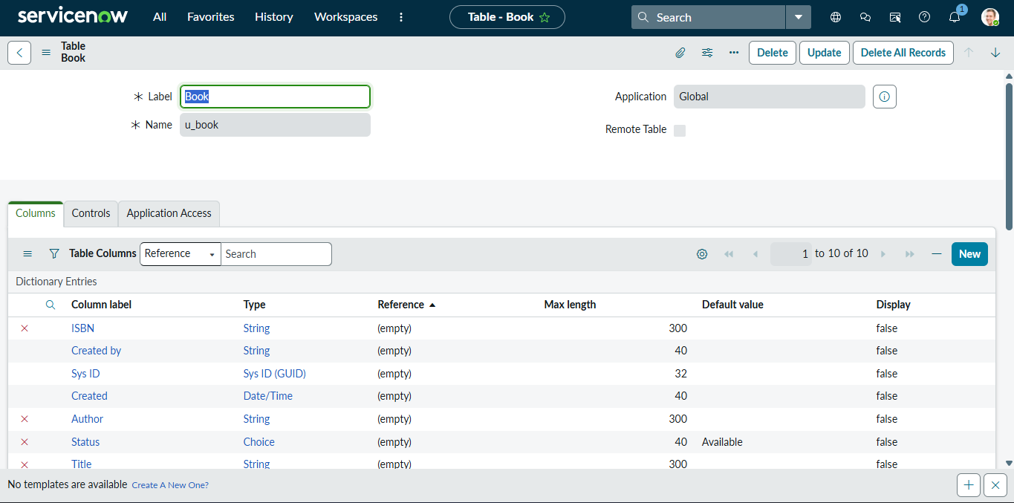
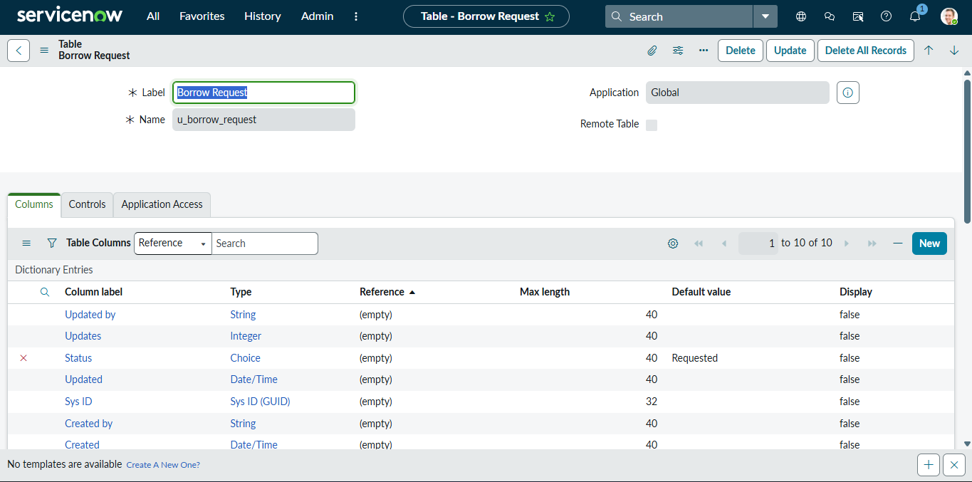

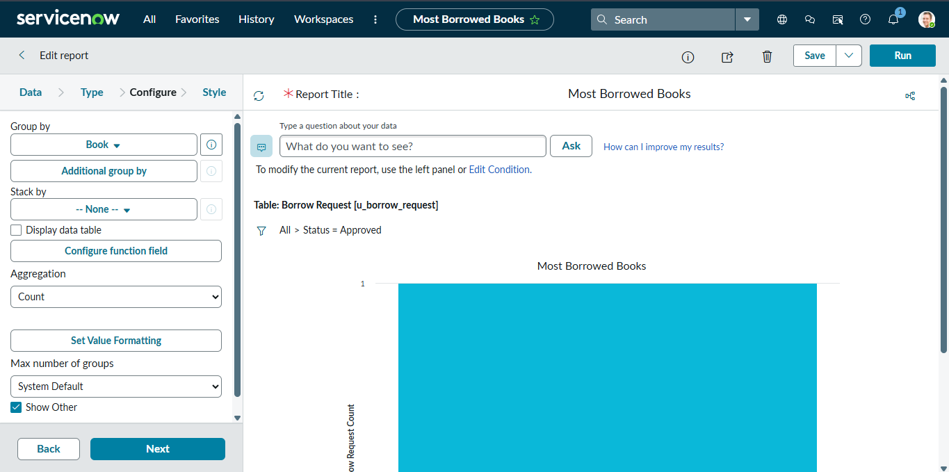

GitHub & Project Demo Link
Add your links here:
- GitHub Link: https://github.com/ponthangaraj-7/Smart-Library-Request-Workflow.git

